Garden City Runners
News Release 5 August 2018

Have You Seen This Guy?
Mystery Running Man Sparks Internet Frenzy
While GCR Tour de parkrun travels to Tring

Miles for Men, Hartlepool
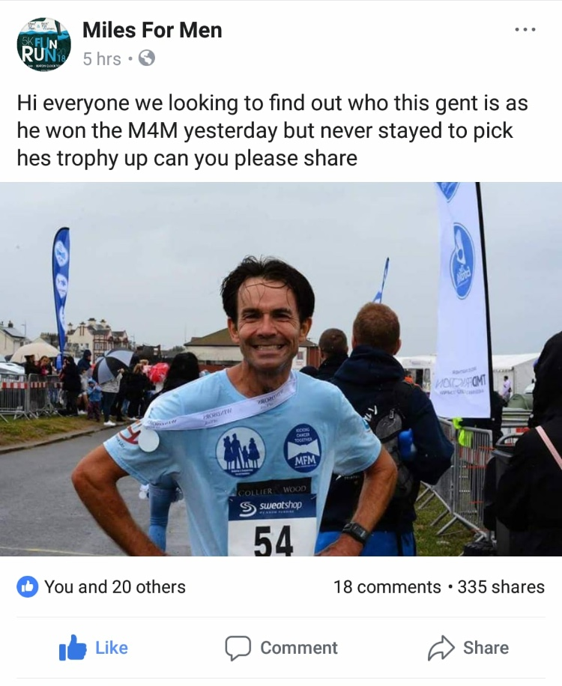
Little did GCR’s PAUL GUY know when he entered and won this 5K race, held in Hartlepool on 29th July in aid of local cancer charities, that he’d end up becoming an internet sensation. Spurning the clearly basic method of matching up the runner’s number with their name and address, organisers Miles for Men shared Paul’s photo on Facebook (above), appealing for anyone who knew the mystery runner to name him so that he might receive his trophy. Despite Paul’s having owned up to his victory, the Facebook post just kept on spreading, with 467 shares at the last tally. We trust that the Miles for Men trophy is now wending its way to the Guy trophy cabinet.

Tring parkrun

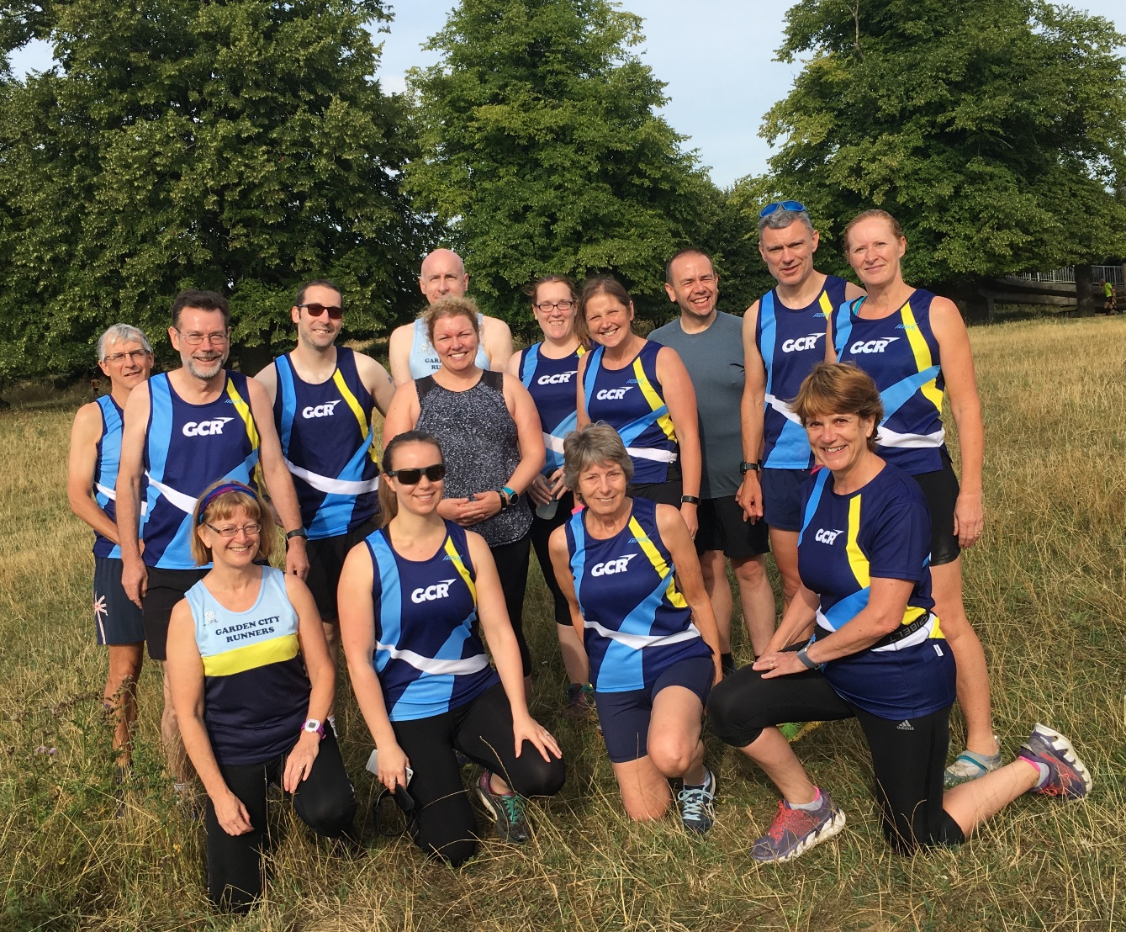

GCRs out in force at Tring parkrun

The inaugural outing of GCR parkrun tourists saw sixteen GCRs travel to Tring, taking on the hilly off-road course in warm conditions. Mystery man PAUL GUY was first GCR into the funnel, finishing 5th in a time of 19:11. Nine places and exactly two minutes behind, group leader RICHARD SOMERSET was 14th in 21:11.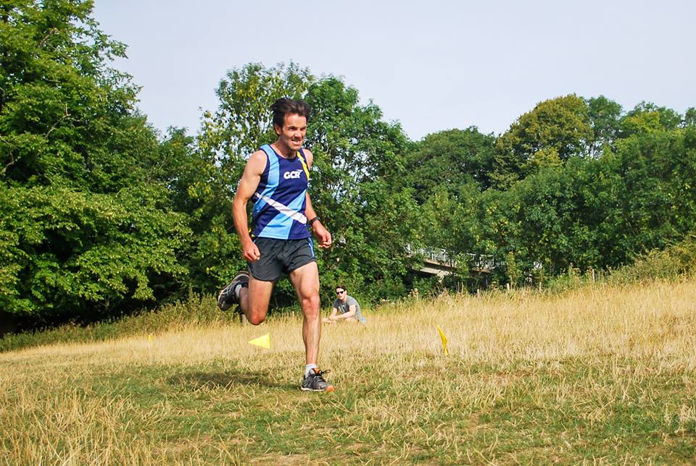

Not in disguise: Paul Guy in action at Tring

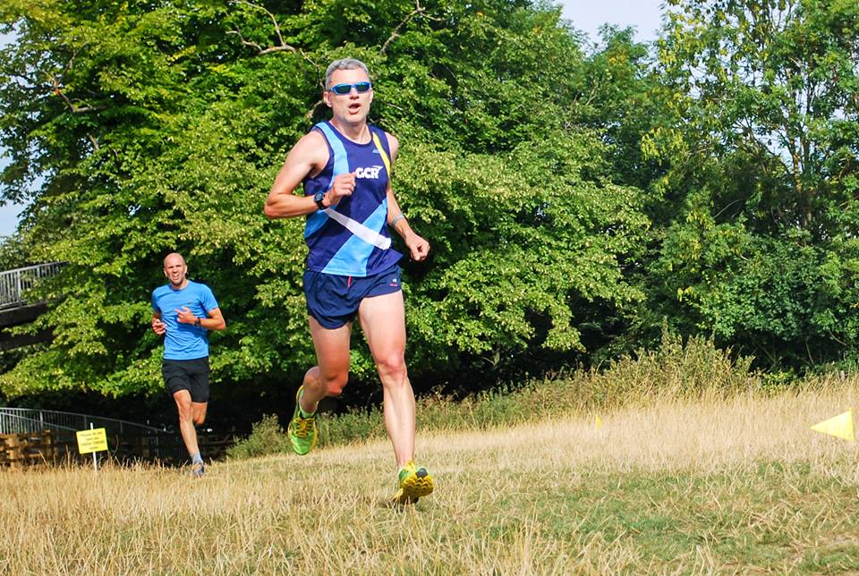

Richard Somerset (above) with his eyes on the prize

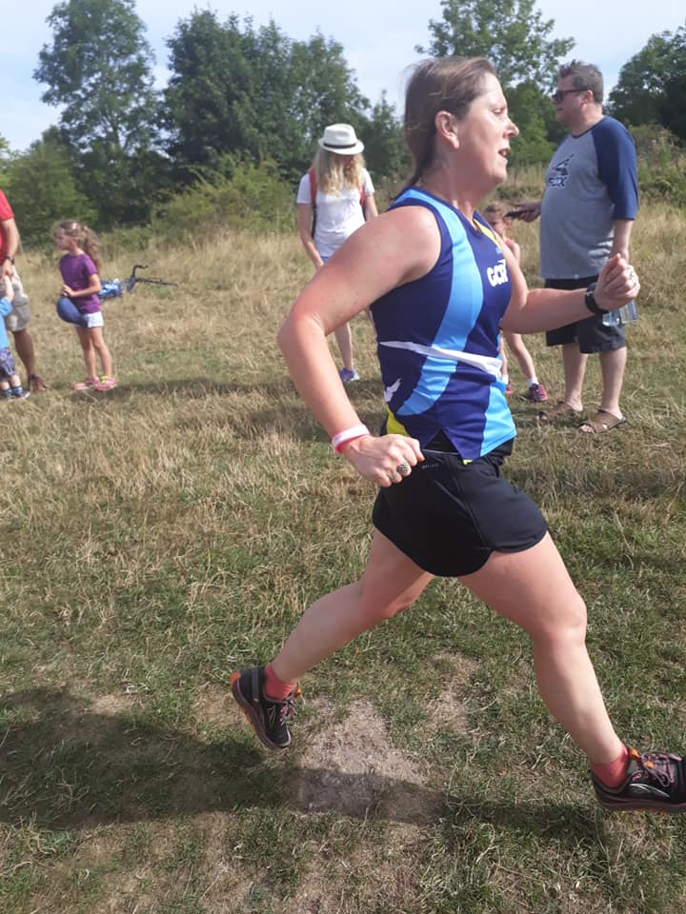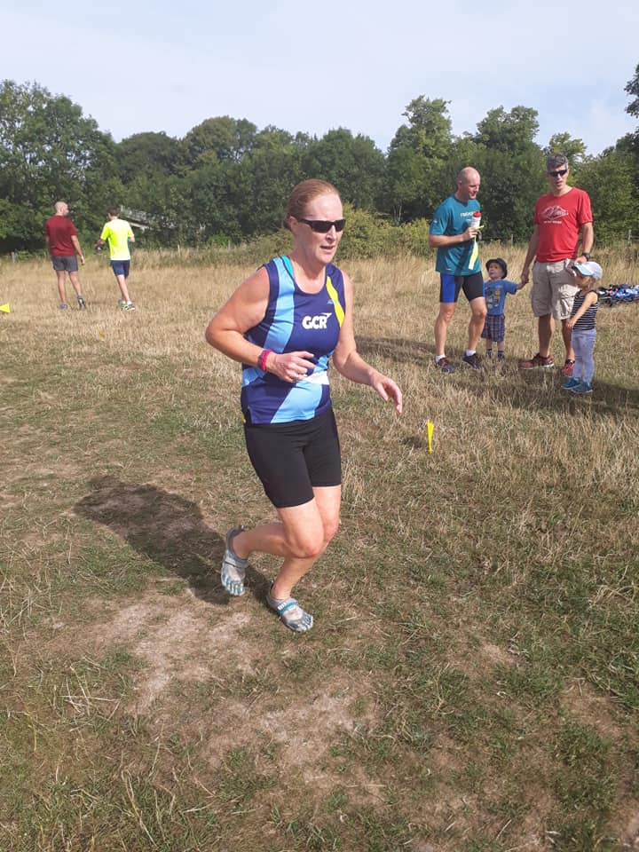

L: Kath Evans literally flying out of the frame; R: Elaine Giles looking cool at the finish

Keep an eye out for news of the next parkrun tour, due in September. A link to the full results of this and Saturday’s other parkruns can be found below.

Riverside Runners 31st Anniversary 10K

GCRs TIM COOKE and TOM WEATHERHEAD travelled to Cambridgeshire to run what Tim describes as “a charming and very interesting mostly off-road course, winding around the Great Ouse to the south of St Neots and crossing the river four times. Tom finished in 50:25 and Tim in 57:24, Tim feeling that he could have done better had it not been so hot, the distance 10K rather than the 10.12K recorded, and had he not very nobly stopped to help another runner search for his wedding ring that he’d dropped on the grass.
Sri Chimnoy Silver Starling 5K, 23rd July
Three GCRs ran in this latest in the Sri Chimnoy race series in London’s Battersea Park. Battling a 30 degree evening heat, our hardy trio nevertheless recorded impressive times, finishing in sight of each other, with NEIL HUME first GCR home, scoring 19th place in 17:06; CRAIG BROWN next in 21st place in a time of 17:10, and JAMES HUISH in 24th place in 17:18. James reports that the race is certainly a PB course, entirely flat and two laps of a large oval loop with no tight corners. The last two races of the summer series take place on 6th and 13th August.

Bob Graham Round Challenge
The ever-modest CHRIS ELAND completed the Bob Graham Round, a fell running challenge in the Lake District covering around 66 miles over 42 peaks with a total ascent of 27,000ft (about the same as climbing Mount Everest) on 20th July. Chris finished the race, which has a cut off time of 24 hours, in 22 hours and 58 minutes. Chris writes: “What a day! After years of dreaming about it - its a bit surreal having actually made it. I had a fantastic support team on both road support, hill support and moral support! The generosity of everyone's donations was amazing and made sure that giving up wasn’t an option.” Chris took on this challenge to raise money for the Alzheimer’s Society, and anyone wishing to support this great cause can do so at Chris’s fundraising page.
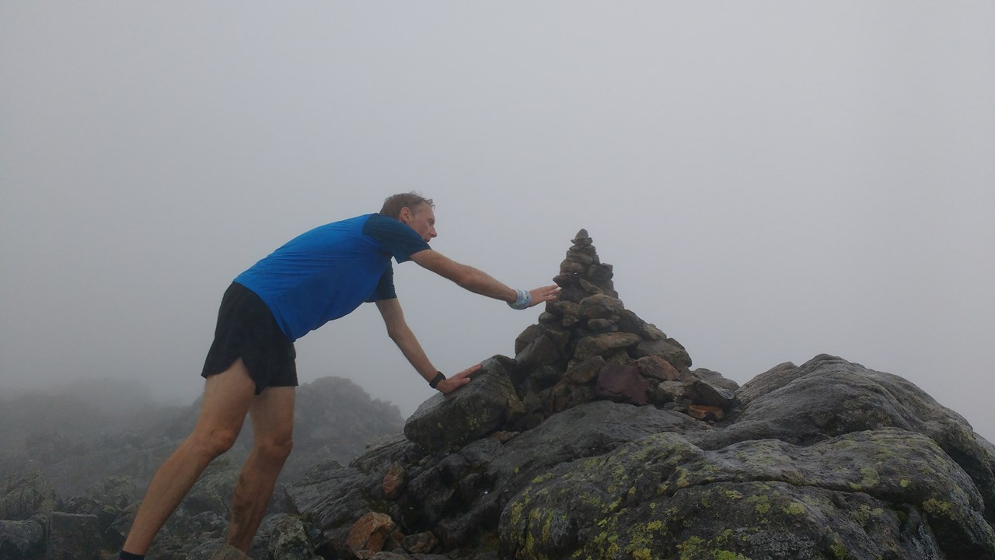

Above: Chris seeks inspiration from the mystical stones

parkrun roundup
Summer holidays see GCRs cramming their trainers into their measly budget airline baggage allowance and trying out parkruns beyond the familiar off-road delights of Hertfordshire. The prize for the furthest travelled goes to AMY ROUTLEDGE, who ran at North Lakes in Queensland, Australia, in a time of 44:51. At Clermont Waterfront parkrun, which takes place at Lake Hiawatha, Florida, STEVE GROUT ran in a time of 26:42 and ÅSA MOBERG GROUT in 31:43. In an intriguing aside, the event was won by two (possibly actual) members of team Space Cadets: BIG RON was overall winner in 16:07 and similarly substantial teammate BIG BECKY was FLop (First Lady of parkrun) in 19:33. At Opole parkrun in Poland, MATTIE LABIAK was 14th overall in 23:11 and mum BARBARA KUBIS-LABIAK was FLop in 24:01. Closer to home, RUSSELL CASEY was third overall at Panshanger in 18:27 and NEIL HUME came in in his customary first place at Ellenbrook Fields in a storming 16:48. Full details of GCRs taking part in this Saturday’s parkruns can be found here.

Avery League 2018

Details of this year’s Avery League races can be found here. The next race is the Welwyn Half Marathon on 9th September. With five races left to run this year, the competition is hotting up, with Thomas Wackett, Neil Hume and Russell Casey leading the men’s table, and Charlotte Jones, Jane Molloy and Kath Evans the women’s.

Forthcoming events
Below is the list of future events. If you know of any others that you think your fellow members would enjoy, please send details to results@gardencityrunners.org.uk.

Event | Date | Time | Online entry
Burnham Beeches Half / 10k | 12th August | 9.30 am | Click here
Stopsley 10m / 5m | 12th August | 10.00 am | click here
Leila’s Run – 10k, Half, ¾ or Full Marathon | 19th August | 8:00 am and 9:00 am | Click here
St Albans Stampede | 1st September | 9:00 am | Click here
Welwyn Half Marathon (postponed from 4 March)  *Avery Race* | 9th September | 9.00 am | Click here
St Paul’s Walden Bury 10k / 5k | 23rd September | 11.30 am | Click here
Hitchin Town Centre 5k | 30th September | 9.00 am | Click here
Willow 10K and 5K, Hatfield House | 7th October | 11.00 am | Click here
Hatfield House Half Marathon and 10k | 14th October | 9.30 am | Click here
Midsummer Series Race 2: Panshanger 5 mile race | 19th July | 7.30pm | click here
Burnham Beeches Half / 10k | 12th August | 9:30am | Click here
Leila’s Run | 19th August |  | Click here
Hitchin Town Centre 5k | 30th September | 9:00am | Click here
Herts 10k | 14th October | 10:0am | Click here

Join Garden City Runners

Do you live in or near Welwyn Garden City? Like running? Garden City Runners is your local running club. It has over 200 members and encourages participation by all. The club has a varied training programme to suit everyone, from working up to 5 kilometres and right through to full marathons.

Try a few sessions before joining. Membership is only £20 per year. Membership forms are available on the GCR website www.gardencityrunners.org.uk. Please ask if you would like a paper copy.

If you want to know more about the Garden City Runners please contact Helen Paine (Secretary) or Sue Fletcher (Membership) at gcr@gardencityrunners.org.uk, visit our website www.gardencityrunners.org.uk or our Facebook page at www.facebook.com/groups/gardencityrunners/.

E N D S

