Garden City Runners
News Release 22nd July 2018

Hot results for GCR in Midsummer Series
Men’s and Ladies’ teams win 5 miler trophies

At the steamy sequel to the Woodhall Estate 5, organised by GCR’s own Gary O’Leary and his excellent team, the GCR ladies’ team won overall 2nd place and the men’s team won overall 1st place. See page 3 for photos and a roll call of prize winners.
Mid Week League 2018

They thought it was all over, but it really is now. The trilogy of reports on the Mob Match finally ends here, with the publication of links to the photo galleries. All photos were shot and edited by GCR’s multi-talented CHARLOTTE JONES.

To see photos of the runners in action, click here.
To see photos of the presentation, click here.

EVENT CATCHUP

Here’s the news that arrived after last week’s copy deadline.

Fairlands Valley Challenge

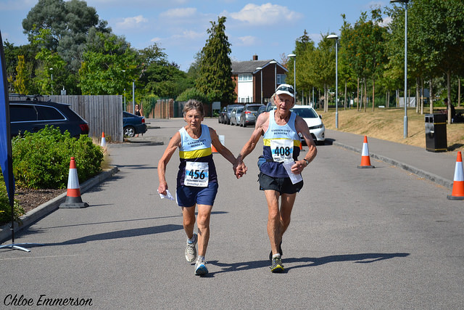
Some wonderful photos were taken by Chloe Emerson, including the one of Eleanor and Dennis Draper above. Click here to see the album.

The official results have been published, here.

THIS WEEK’S EVENTS

Panshanger Park 5

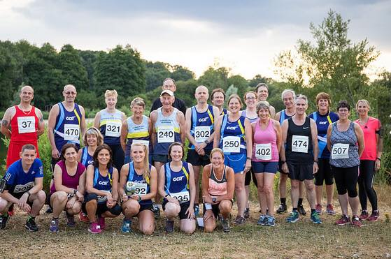

Pictured above are many members of the GCR crack squad who donned their running aprons and cleaned up at this event, and also over the pair of races. Most effective at wiping out the opposition was BECCA HAYDEN, who reports the evening race as being very hilly and still quite humid, who was 3rd lady on the night and overall 1st lady!

Pictured below is the ladies team of ANNE HAYDEN, BECCA HAYDEN, ANNE HENSON, and CAROL REID, who won overall 2nd ladies’ team trophies.

BARBARA KUBIS-LABIAK and ANNE HENSON were each 1st in their age categories.

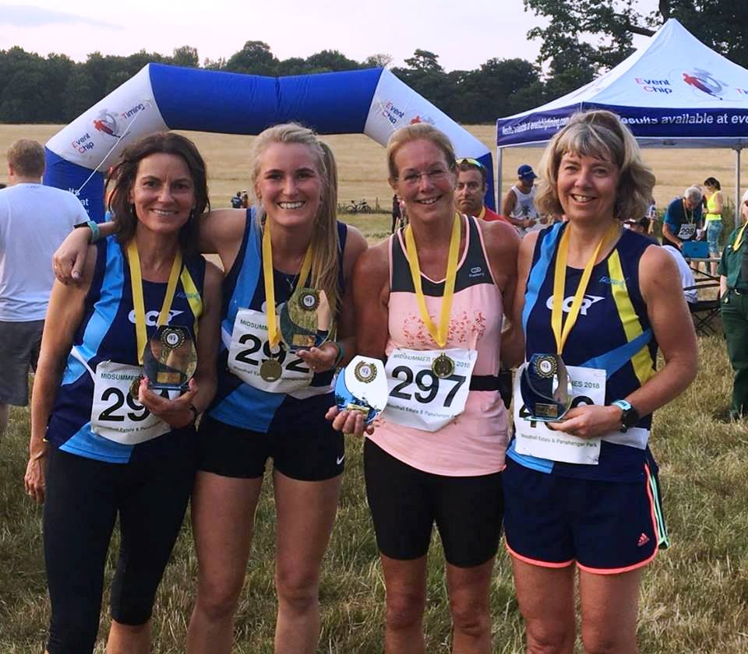

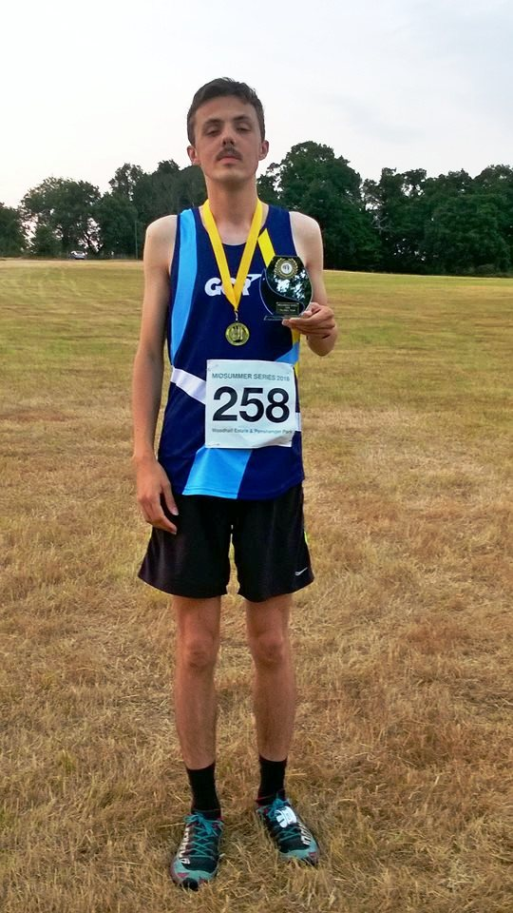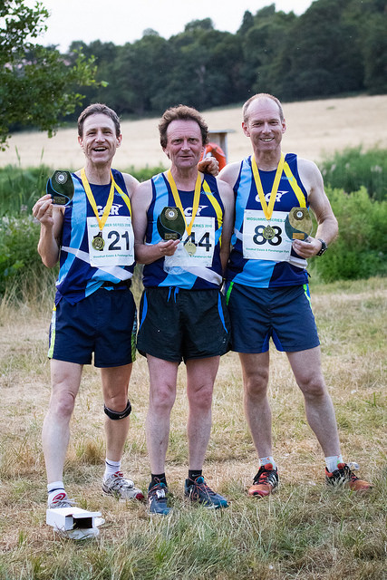

Above is the men’s team comprising DANIEL FIGG, captain SEAN BOWEN, DAVID EDWARDS, and TIM COOKE, who won overall 1st men’s team trophies.

The complete list of GCR members positions and times is shown below. For the full results, click here. For the photo gallery, courtesy of event photographer Gary Sherrin, click here.

Position | Name | Chip time | Age Cat Position
7  14  19  21  59  66  71  77  79  101  115  117  120  123  124  129  153  173  174  186  189  196  216  217  229  233  235  237  238  239  244 | Daniel Figg  Sean Bowen  Justin Hill  Becca Hayden  Ali Eroglu  David Edwards  Paul Butler  Barbara Kubis-Labiak  Kay Metcalfe  Anne Henson  Robert Saville  Matthew Hunt  Carol Reid  David Selwood  Ann Hayden  Tim Cooke  Maggie Wright  David Hale  Peter Lapthorne  Melanie King  Kath Evans  Emma Dempster  Jane Molloy  Linda Hamm  Dennis Draper  Charlotte Jones  Maureen Steed  Dawn Redwood  Eleanor Draper  Jennifer Hill  Ali Christie | 00:30:22  00:32:49  00:33:22  00:33:37  00:39:30  00:40:10  00:40:24  00:40:57  00:40:59  00:43:07  00:44:52  00:44:56  00:45:19  00:45:42  00:45:55  00:45:59  00:47:39  00:50:55  00:50:56  00:52:49  00:52:58  00:54:09  00:57:29  00:57:28  01:01:04  01:05:04  01:05:12  01:06:19  01:06:55  01:11:07  01:16:10 | 6  2  4  3  2  3  11  1  2  1  31  33  7  5  8  21  14  29  30  19  20  19  7  25  15  41  8  30  9  43  33

Elmbridge 10k

SEAN BOWEN travelled 50 miles to the suburban Surrey sprawl of Walton-on-Thames for the Elmbridge 10K. He finished 86th of 589 in 39:50. Coming in to the finish across the car park, he spotted marshalling former GCR members KATHERINE and STEPHEN IND - Chairman and former treasurer of the host club Elmbridge Road Runners. Katherine said "we're only a small club - only 100 members or so, and we have to ask every single member either to help or race!"
The event forms part of the Surrey Road Race League, so it's packed with the club colours of the likes of [Croydon] Stragglers, Epsom Oddballs, Clapham Chasers, South London Harriers, Ranelagh Harriers, etc. First finisher was GB international Scott Overall of Blackheath and Bromley Harriers in 30:50 - starting his warmup for the Berlin marathon.

Bath Off-Road Marathon

NICK GENEVER continued his relentless series of trail marathons, taking part in this trail race in the hills and valleys around Bath, with a total ascent of 960m. Starting from the University, Nick reports that the course went down to a canal section, then followed an ardous 2-lap circuit taking in a mile long climb up Fosse Way and a steep descent from Solsbury Hill. The final mile was uphill from the canal to the University. Conditions were very hot and humid, and Nick finished in 5:05:41.

Conti Thunder Run 24

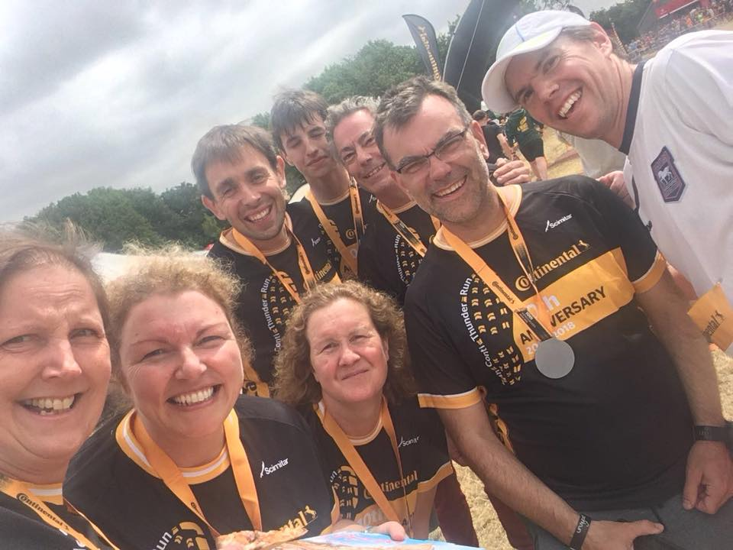

"Breaking Brad and his Muddy Disciples" included four GCRs - BRAD SMITH (Captain), KATH EVANS, ALEX YATES and JACQUELINE MCCALLUM. Their mixed team of 8 included some friends from Beehive junior parkrun (Scott Clarke, Gareth Fuller, Paul Bliss and Daniel Pudner), and finished 101st place out of 215 in the mixed large teams category. The team completed 23 laps of a challenging technical and hilly 10k course in 24:30:15, enduring rather hot conditions, albeit somewhat dryer than in 2017.

parkrun roundup

Members’ results from all parkruns (except Ellenbrook Fields) are shown in the following table.

Podium placers were Paul Guy, 1st finisher at Heartwood Forest, who also achieved a new venue PB of 17:55, and Neil Hume, 1st finisher at Ellenbrook Fields in 16:54. Charlee Chapman achieved a significant PB of 23:46 at her first appearance at Stevenage, Helen Moye at Sherringham, and at Panshanger new PBers were Tom Wackett, Ryan Kean, and Linda Hamm. Thomas Parmley and Ciaran Welsh set new PBs at Ellenbrook Fields. ‘Gratulacje’ to Mattie LABIAK, who was the furthest afield, running at Opole parkrun in Poland!

Course | GCR Member | Time
Heartwood Forest | Paul GUY  Russell CASEY  Wendy WALSH  Richard SIDLIN  Craig STEPHENSON | 17:55  18:51  20:44  23:21  25:22
St Albans | Andrew HOLT | 18:37
Cambridge | Joseph PRICE | 20:16
Eastleigh | Simon BETTERIDGE | 38:25
Oak Hill | Tom CASSERLEY | 36:59
Poole | Garden City Runners | 25:58
Winchester | Sue FLETCHER | 40:34
Stevenage | Charlotte CHAPMAN  Tichaonezvi J. RUREDZO | 23:46  37:20
Gunpowder | Sally LAFLIN | 28:34
Sheringham | Helen MOYE | 26:37
Panshanger | Thomas WACKETT  Richard WILLCOX  Robert CASSERLEY  Malcolm DOWN  Justin HILL  Neil BRITTAIN  Ryan KEAN  Barbara KUBIS-LABIAK  Johan PREIS  Sam SMITH  Tom ROGERS  July KEAN  Linda HAMM  Peter LAPTHORNE  Beth CASSERLEY  Charlotte JONES  Alison CHRISTIE | 18:45  19:17  19:31  19:36  19:39  20:07  21:11  24:27  24:31  26:13  26:53  27:45  29:28  30:11  35:51  36:30  42:29
Harlow | Lynette STEWART | 32:05
Opole | Mattie LABIAK | 22:38
Ellenbrook Fields | Neil HUME  Rob HUGHES  Caroline HALE  Michael TANDY  Nigel CAVILL  Michael PAINE  Rebecca BARDEN  Yvonne JONES  Michael WISE  Louise BEALE  David SELWOOD  Wayne AYLOTT  Robert CARTWRIGHT  Thomas PARMLEY  David HALE  Claire HARLOW  Simon HARLOW  Jennifer DENMAN  Caroline HUGHES  Asa MOBERG GROUT  Ciaran WELSH  Emily HAMMOND | 16:54  19:50  20:16  21:02  21:16  22:16  22:37  24:42  25:16  25:44  25:58  26:37  27:00  27:15  27:31  27:32  27:40  28:29  30:19  30:36  31:57  32:06
Cwmbran | Steve GROUT | 26:03
Letchworth | Louise SMITH | 29:29

Avery League 2018

Details of the 2018 Avery League can be found here.
The next Avery race is the Fairlands 3k Relays on Thursday 26th July. If you want to take part and haven’t yet entered, contact your captain straight away; email Sean Bowen or Charlee Chapman.

Note that the 10th Avery race, the Standalone 10k, is 93% full already, so you need to enter immediately if you want to be in it!

GCR Strava Group
If you’d like to join the GCR Strava community; click here for details of the group.

Forthcoming events
Below is the list of future events. If you know of any others that you think your fellow members would enjoy, please send details to results@gardencityrunners.org.uk.

Briefly looking ahead to the culmination of the Mid Week League, the Mob Match will be hosted by GCR on Thursday 12th July, at SFO; offers from GCR members for marshalling will be warmly welcomed – please contact Sean Bowen at sean.bowen.gcr@hotmail.co.uk.

Event | Date | Time | Online entry
Fairlands Valley Relays | 26th July | 7:30pm | See your captain
Burnham Beeches Half / 10k | 12th August | 9:30am | Click here
St Albans 10k | 12th August | 10:00am | Click here
Stopsley 10m / 5m | 12th August | 10:00am | Click here
Leila’s Run  10k, ½ , ¾ or Full Marathon | 19th August | 8:00am  &  9:00am | Click here
St Albans Stampede | 1st September | 9:00am | Click here
Hatfield 5k Series Race #1  (including Herts Senior Champs) | 5th September | TBA | Click here
Welwyn Half Marathon  (postponed from 4th March)  *Avery Race* | 9th September | 9:00am | Click here
Round Norfolk Relay | 15th/16th September | 6:00am | See Sean Bowen
Hatfield 5k Series Race #2  (including Herts Vets Champs) | 19th September | TBA | Click here
St Paul’s Walden Bury Run | 23rd September | 11:30am | Click here
Beginners’ Course #9 Starts | 25th September | 7:15pm
Hitchin Town Centre 5k  *** only 46 places left *** | 30th September | 9:00am | Click here
Hatfield 5k Series Race #3 | 3rd October | TBA | Click here
Standalone 10k  *Avery Race* | 7th October | 9:30am | Click here
Hatfield House Half and 10k | 14th October | 9:30am | Click here
Herts 10k | 14th October | 10:00am | Click here

Join Garden City Runners

Do you live in or near Welwyn Garden City? Do you like running? Garden City Runners is your local running club, has over 250 members, and encourages participation by all. The club has a varied training programme to suit everyone, from working up to 5 kilometres and right through to full marathons.

Try a few sessions before joining. Membership is only £20 per year. Membership forms are available on the GCR website www.gardencityrunners.org.uk. Please ask if you would like a paper copy.

If you want to know more about the Garden City Runners please contact Helen Paine (Secretary) or Sue Fletcher (Membership) at gcr@gardencityrunners.org.uk, visit our website www.gardencityrunners.org.uk or our Facebook page at www.facebook.com/groups/gardencityrunners/.

E N D S

