Garden City Runners
News Release 15 July 2018

GCR Triumphs at Mob Match
Team takes top spot and hosts a stellar evening

What a magnificent team effort! Thursday night’s finale to the Midweek League season gave us just the tonic we needed after watching England lose to Croatia the night before, with Team GCR crowned race champions. The impressiveness of our runners was matched by the fantastic contribution of all our members who sacrificed running to take on marshalling or other supporting roles instead.
Elsewhere this week, we saw our latest group of beginners graduate at Panshanger parkrun, ELAINE GILES conquering the 100k Race to the Stones Ultra, and several members competing in the self-navigating, multi-distance Fairlands Valley Challenge.
Midweek League Mob Match
Garden City Runners hosted this end-of-season extravaganza, superbly choreographed by Course Director, PETER HARVEY, who ensured that all runners – almost 500 – got safely round. At this event, the three Scott’s Travel Midweek League divisions come together to pound the streets of WGC before descending like a plague of locusts on the buffet at SFO, valiantly provided by ANNE HENSON and her team of volunteers. This was followed by the presentation of the season’s awards (already reported).
Team GCR brilliantly won the night’s race, ahead of all this season’s first division teams, which bodes well for next year’s competition. GCR earned top spot by virtue of the men’s team taking second place and the ladies’ team third position. In addition, we also claimed top Vets prize, with men’s GCR Vets first and ladies third.

JAMES HUISH, PETER HARVEY (Course Director) and SEAN BOWEN (Men’s Captain)
In the men’s race, NEIL HUME was first GCR, 2nd VET and 6th overall in a time of 34:33. Next GCR back was CRAIG BROWN 36:08, followed by BRUCE JUDGE 36:49; CHRIS JONES 37:31; PAUL GUY 37:42; DANIEL FIGG 37:47; ROB CASSERLEY 38:03; TOM WACKETT 38:18; RICHARD WILLCOX 38:32; RICHARD SOMERSET 39:24; SEAN BOWEN 40:07; JUSTIN HILL 40:13; MALCOLM DOWN 41:24; ROB HUGHES 42:05; ANDY HOLT 42:20; JAMES DUNMORE 42:26; MATTIE LABIAK 42:33; LORENZO FRANCHI 43:10; ANDREW TOMLINSON 44:26; MICHAEL TANDY 45:09; MICHAEL PAINE 46:50; ALISTER PARRY 47:39; NIGEL CAVILL 49:01; ALI EROGLU 49:21; ANDREW NEWBURY 50:39; STEVE CROUT 50:51; GARY FAIRES 51:18; GARY O’LEARY 51:41; JOHN WARDEN 53:07; PAUL GATENS 54:30; RICHARD BROWN 59:31; TOM PARMLEY 1:02:23 and OWEN GALLAGHER 1:03:30.

In the Women’s race, CAROLINE HALE was first GCR home in a time of 42:50, followed by ZOE STEPHENS 44:55; REBECCA BARDEN 47:02; JULIA WIPER 47:28; KAY METCALFE 50:15; BARBARA KUBIS-LABIAK 51:23; DANITA BEETGE 53:33; JENNIFER DENMAN 1:02:23; CAROLINE HUGHES 1:05:51 and EMMA DEMPSTER 1:09:04.

The Men’s race was won by AFEWERK ROSSOM of Herts Phoenix (31:54) and the Women’s by BETTY BOHANE of Royston Runners (39:39).

Beginners Graduation
This Saturday, our latest group of couch-2-5k beginners graduated at Panshanger parkrun. CHARLOTTE JONES, who has guided them over the last 10 weeks, was on hand to take photos to record the sprint finishes, present medals, and offer delicious home-made flapjacks.
Other commitments (and going to the wrong park!) meant that a number of beginners were unable to enjoy the occasion and will do their graduation parkrun at a later date.
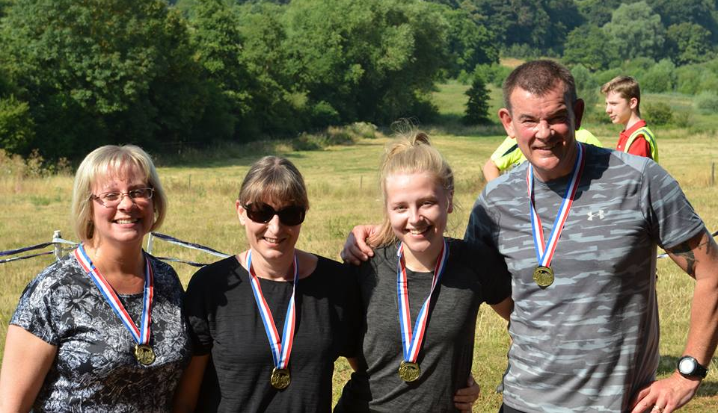 | Proud graduates Sue Henson, Fiona Selwood, Jenn Hill and Curt Wise

A total of 29 club members ran this parkrun, many turning out in their club vests to greet and cheer on the graduates. | 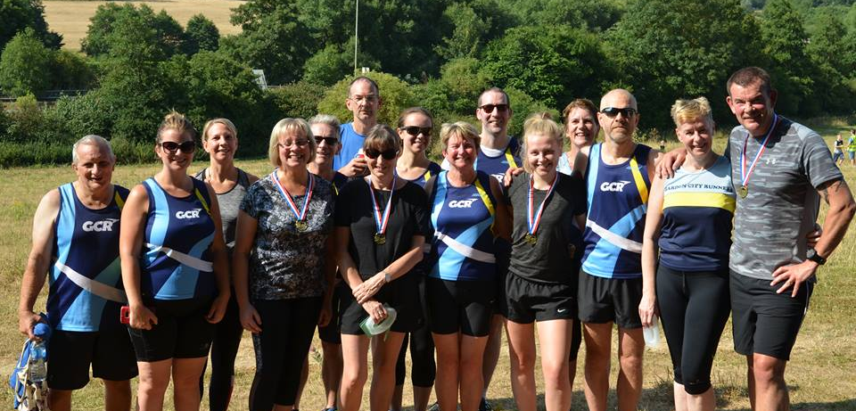
Our next beginners course is scheduled to begin on 25 September and will be led by KAREN ATKINSON. Please let friends, family and colleagues know and download the flyer from the GCR website or Facebook page to post around notice-boards at work, schools/colleges, and GP surgeries.
Fairlands Valley Challenge
Several GCR members participated in this popular local event, with a range of distances to choose from. The race starts in Stevenage and wends its way around various Hertfordshire villages including Bramfield, Datchworth and Tewin. As the race is self-navigating, most participants seem to do a bit more than the official distance. However, REBECCA BARDEN reports that the extra effort and the excessive heat were more than compensated for by the “beautiful views and bread-and-butter pudding at the checkpoints”!
ALAN ROUTLEDGE CHARLOTTE JONES & BRAD SMITH braved the 50k ultra. Provisional results have ALAN ROUTLEDGE finishing in 11th place in 5h 38m. BRAD SMITH finished in 6H 47M and CHARLOTTE JONES IN 9h 23m. BRAD confesses “This was my first ultra, in the heat, on no specific training. I will train properly next time!”
Just one of our members, NICK GENEVER, chose the marathon distance and was third home in 4h 13m. Opting for the 18 mile route, ANNE HENSON and SAM MALES were the first GCR’s back, finishing commendably in joint third position in a time of 3h 00m. Next GCR’s to finish, coming in together in 3h 53m, were REBECCA BARDEN, EMMA FERRY and BECCA HAYDEN. Club legends, DENNIS and ELEANOR DRAPER, also did the 18m route and completed it in 6h 42m.

All results are provisional at this time and any significant updates/additions will be reported next week.
Emma Ferry, Rebecca Barden and Becca Hayden all smiles after completing 18m at Fairlands Valley Challenge | 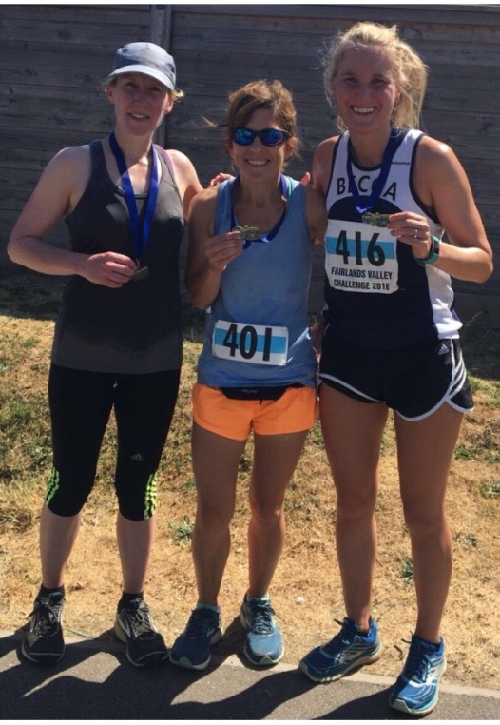
Race to the Stones 100k

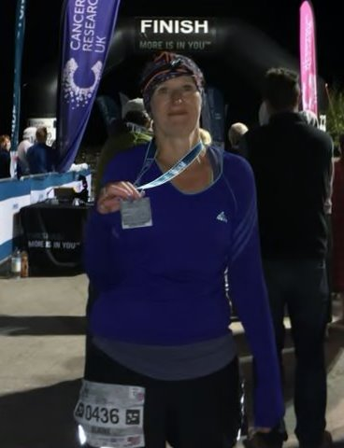 | On Saturday, ELAINE GILES set out on this 100k challenge, with participants invited to run, walk or jog along the Ridgeway over 1 or 2 days. Despite being side-lined by injury in recent weeks and doing rather more swimming than running, ELAINE opted to go for the 100k in 1 day. She completed the distance in 18h 57 40s.  Looking a combination of triumphant and spaced-out at the end, she requested “Shoot me if I ever want to do 100k again”!

Furzton Relays
MALCOLM DOWN travelled to Milton Keynes on Saturday to participate in this fairly new event, organised by Redway Runners. The race requires teams of four to complete 10m around Furzton Lake, with each team member running one leg of 2.5m. MALCOLM’s team managed 6th place overall and 5th Mixed team and he completed his 2.5 Miles in 15:41.
He recommends the event, “Definitely worth considering for next year - the course is flat and the event is well organised with runners of all abilities”.

Parkrun Round-Up

Congratulations to HELEN MOYE who this week ran her 100th parkrun, completing the Sheringham course in 28:02 and coming home as 10th lady. TOM WACKETT took first place at Pymmes (Edmonton) in18:43. At Ellenbrook Fields, NEIL HUME was first (16:54) and REBECCA BARDEN first lady (22:44). CRAIG BROWN came in second (17:14) and JAMES HUISH fifth, with a PB of 17:52. HANNAH FRANK was fifth lady at Panshanger in 22:41, and SEAN BOWEN fifth at Castle Park in 19:24.

Other course PB’s were achieved this week at
- Panshanger – ROB CARTWRIGHT 28:19; JEN DENMAN 30:46; and SUE HUNT 35:25.
- Weymouth – CAROLINE HUGHES 30:08
- Ellenbrook Fields – CIARAN WELSH 32:04.

Consolidated results for all our club runners at this Saturday’s parkruns can be found here

GCR Annual General Meeting – Monday 16 July
Please support your club and join us for the AGM this Monday, 16th July. Refreshments will be available from 7pm - Pimms and scones - and Sue Fletcher will be on hand to take payment for renewal of your club membership.

Venue - B block classroom, Sir Frederic Osborn School (see below for a link to a site map). Park in main school car parks and follow the signs.
Time - 7pm for 7.30pm
http://www.sfosborn.herts.sch.uk/contact-us

Forthcoming events

Fairlands Valley 3k Relays
This race, happening on Thursday 26th July, is the second biggest event in the GCR Calendar, in terms of member participation. There are opportunities for runners of every ability/pace to take part in men's teams of five, women's teams of three, and – for the first time - mixed teams of four; two men & two women. We can enter as many of each as we have names for, and the race entry fees are free to individual members, as they are covered by the club race subsidy budget. Please let your team captains know if you're interested in running ASAP by email or text to:
Men - sean.bowen.gcr@hotmail.co.uk / 07802 382596
Women - charlotte.chapman27@live.co.uk / 07986 326518
You will need to provide:
NAME
DATE OF BIRTH (if you're newish and not on our files)
PREDICTED TIME FOR 3km (to help in placing you in a team of similar pace)
LEG PREFERENCE (early leg if you can get there early or need to leave early, later leg if you're not going to be able to get there in time to start by 7:30pm)
…..and whether you'd consider making up a mixed team.

If you want to come as a pre-determined team line-up, then please let Sean and Charlotte know all names together (this particularly applies to mixed fours). If you only give us your own name, then you’ll be assigned to a team of similar pace.
Essentials:
- GCR member paid-up for 2018-19 (2nd claim fine unless your 1st claim club is also competing)
- GCR vest
- Capable of completing 3km
- Insect repellent

Other Events

The table below gives a selection of future events. If you know of others that you think fellow members would enjoy, please send details to results@gardencityrunners.org.uk.

Please note that the Standalone 10k in October is nearly full, and as it’s an Avery race, then please hurry to sign up to avoid disappointment

Event | Date | Time | Online entry
GCR Club AGM – SFO | 16th July | 7.30 pm
Midsummer Series Race 2 – Panshanger Park 5m | 19th July | 7.30 pm | Click here
Burnham Beeches Half / 10k | 12th August | 9.30 am | Click here
Stopsley 10m / 5m | 12th August | 10.00 am | click here
Leila’s Run – 10k, Half, ¾ or Full Marathon | 19th August | 8:00 am and 9:00 am | Click here
St Albans Stampede | 1st September | 9:00 am | Click here
Welwyn Half Marathon (postponed from 4 March)  *Avery Race* | 9th September | 9.00 am | Click here
St Paul’s Walden Bury 10k / 5k | 23rd September | 11.30 am | Click here
Hitchin Town Centre 5k | 30th September | 9.00 am | Click here
Hatfield House Half Marathon and 10k | 14th October | 9.30 am | Click here
Standalone 10k  *Avery Race* | 7th October | 9.30 am | click here
Herts 10k | 14th October | 10:00 am | Click here

Join Garden City Runners

Do you live in or near Welwyn Garden City? Like running? Garden City Runners is your local running club. It has over 200 members and encourages participation by all. The club has a varied training programme to suit everyone, from working up to 5 kilometres and right through to full marathons.
Try a few sessions before joining. Membership is only £20 per year. Membership forms are available on the GCR website www.gardencityrunners.org.uk. Please ask if you would like a paper copy.
If you want to know more about the Garden City Runners please contact Helen Paine (Secretary) or Sue Fletcher (Membership) at gcr@gardencityrunners.org.uk, visit our website www.gardencityrunners.org.uk or our Facebook page at www.facebook.com/groups/gardencityrunners/.

E N D S

